Technical Design Document

AIMS - Apprentice Internship Management System

ADDENDUM – ADMIN WEB WIREFRAMES



1. **Version History**

|  |  |  |
| --- | --- | --- |
| **Date** | **Author** | **Description** |
| 07/25/16 | Michael Fiore | Initial Draft |
| 08/18/16 | Tiffany Trusty | Updates |
|  |  |  |
|  |  |  |

1. **Acronyms**

|  |  |
| --- | --- |
| **Acronym** | **Definition** |
| SOW | Statement of Work |
| TDD | Technical Design Document |
| AIMS | Apprentice Internship Management System |
|  |  |
|  |  |
|  |  |

1. **References**
2. AIMS SOW, EFC Salesforce / Tinderbox
3. **Table of Contents**
4. Version History
5. Acronyms
6. References
7. Table of Contents
8. Introduction
9. Overall Flow
10. Wireframes
    1. Timesheets List
    2. Create Event
    3. Create Group
    4. Create Organization
    5. Create User
    6. Edit Survey
    7. Event
    8. Events
    9. Find Users Report
    10. Group
    11. Groups
    12. Home
    13. Login
    14. Manage Props
    15. Organization
    16. Organizations
    17. Properties
    18. Survey Create
    19. Survey Responses
    20. Survey
    21. Surveys
    22. Timesheet
    23. User Profile
11. Appendix A – Discussion Records
12. **Introduction**

This is an addendum to the AIMS TDD. It elaborates on the web wireframe design.

1. **Overall Flow**

<http://popplet.com/app/#/3349750>

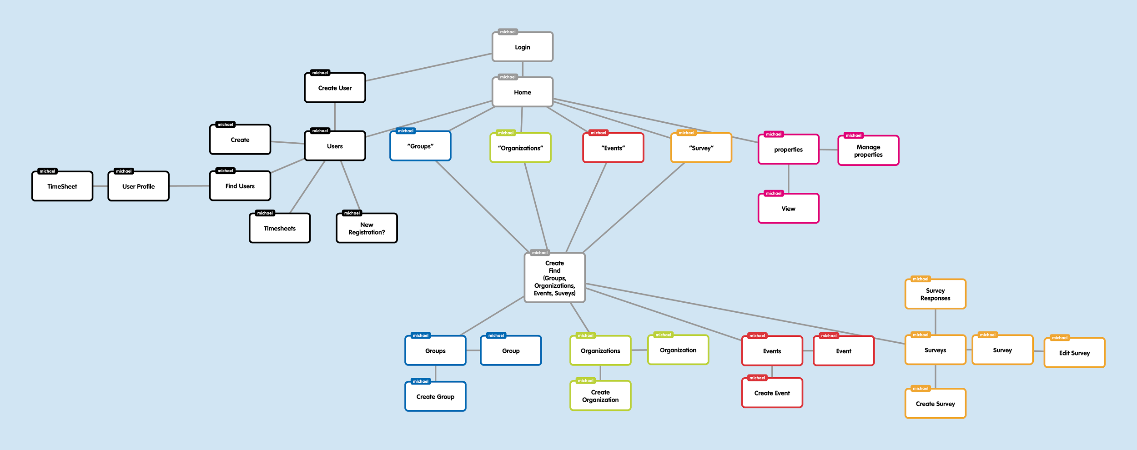

1. **Wireframes**

## Timesheets List

Timesheets — Admin side table of all timesheets of “employees”.

It is important for the teacher to check up on their students time logging, this view will show the timesheet of all students based on group and the teacher can now select a student to look deeper into the time log.

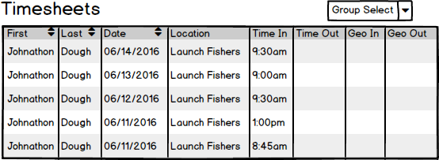

## Create Event

Create Event — A view to create calendar logged event/meeting. This is going to be admin side, the event can be assigned to a group(s) and share when and where it is.

When a user needs to assign a time for a meeting to occur, they go to this to add it to their digital calendar.

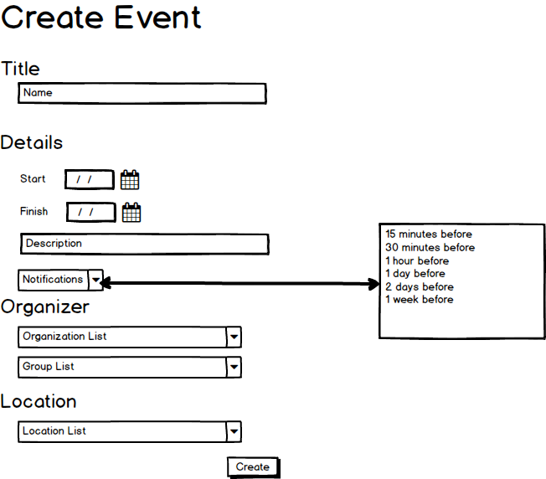

## Create Group

## Create Organization

Create Organization — Organizations will be special outside of Eleven Fifty contacts. With this we would like to store their basic credentials Name, Address, and Contact info(Phone Number)

Someone has just made a connection to an outside company that seems interested or is already connected to the apprentices. Someone would want to go into here and set them up as an organization to further talking points and connecting them to apprentices.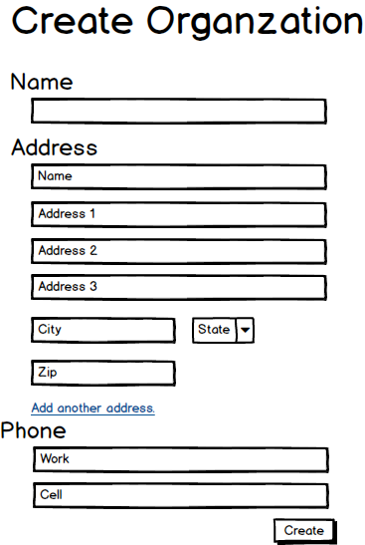

## Create User

Create User — A view to create a user with this we would like to store their basic credentials Name, Address, and Contact info(Phone Number)

Create a user so that one can traverse the application.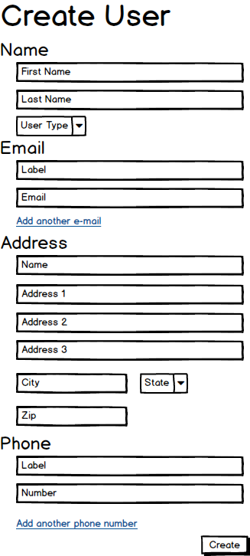

## Edit Survey

Edit Survey — In this view, it will take a collection of questions based off of a name of a survey, this this view one will be able to edit the all fields that are tied to surveys.

The user made a typo, or some information has changed, we have to provide a way that they can edit it and this is the section to do so.

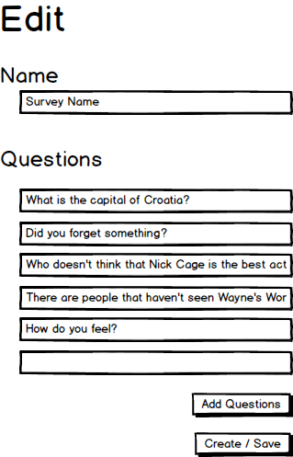

## Event

Event — When selected, this will display start and finish time of the event, a small blurb about what it is, and a maps representation of the location.

This is the “additional detail” of an event, so when someone who wants more information on an even they can go into this view to find out more.

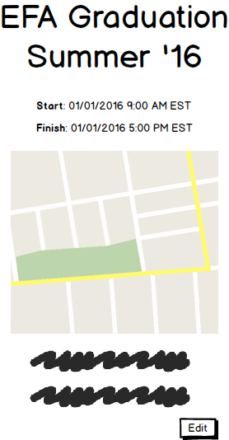

## Events

Events — Parent view to an event, this will display all events in a table with a “detail” button to take you into more specific information on the event.

One user could have many events coming up, they would want to be able to see and organize a list of them, and have the ability to chose an individual event to find out more info.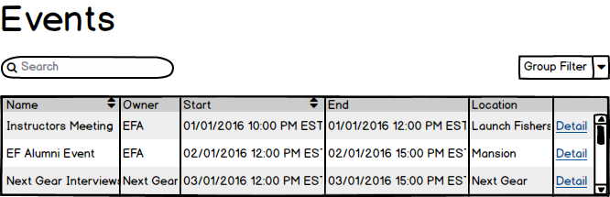

## Find Users Report

Find Users — Displays a table of all users and their types, groups, and allows and Admin to go deeper into the details of user. This table will have a search bar.

When a teacher (admin) needs to find or give out certain information about a student (basic user) this functionality to read into the student.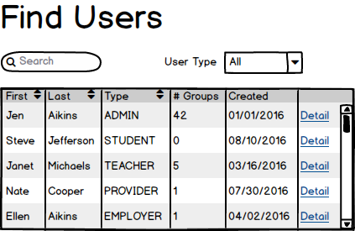

## Group

Group — Displays who is in the group and their role, Admin’s can add users to the group from here.

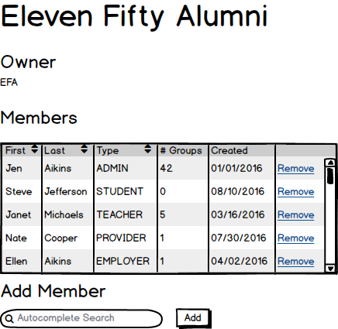A new class could be starting up and with this the teacher can now add all the appropriate students to the group so they can be organized all together.

## Groups

Groups — Parent view to a Group, this will display all groups in a table with a “detail” button to take you into more specific information on the event.

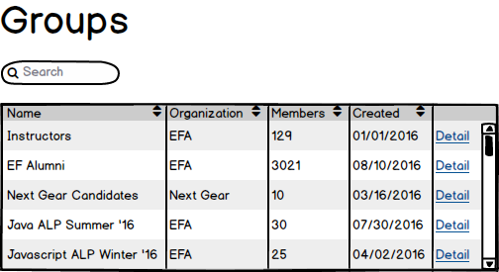The teacher has now worked for EFA for awhile now and has many current and former classes, therefore many groups and will want a way to organize and view them all together.

## Home

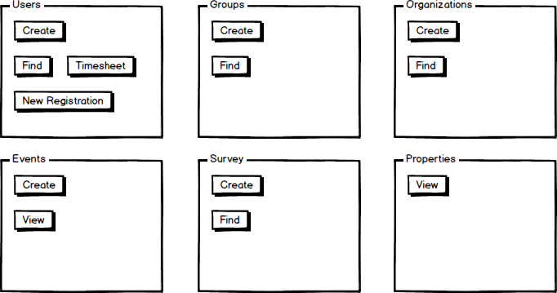Home — Start page for an admin, with bootstrap col(rule of 12) tiles. The individual tiles will have the relevant functionality to the feature, review wireframe for details.

Every time a user starts up the app, this will be the home hub location to get to everything necessary.

## Login

Login — Start up page for any user (admin/student) if login is not stored. User and password required.

Simple view to log in to the app.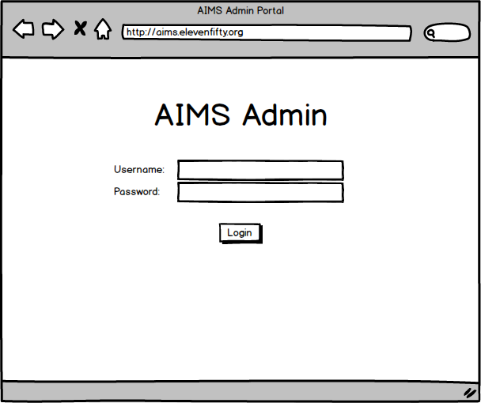

## Manage Props

Manage Props — For the users, if any information(properties) needs to be edited, this view will provide the functionality. Fields are carried from the user fields.

The student after completing the course has many new skills, he/she will go back into their profile and update all the new great skills they have.

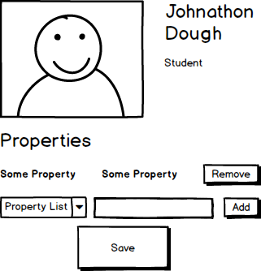

## Organization

Organization — Displays all organizations info, with a focus on maps location and what events and the times of the events are being held are at this organization.

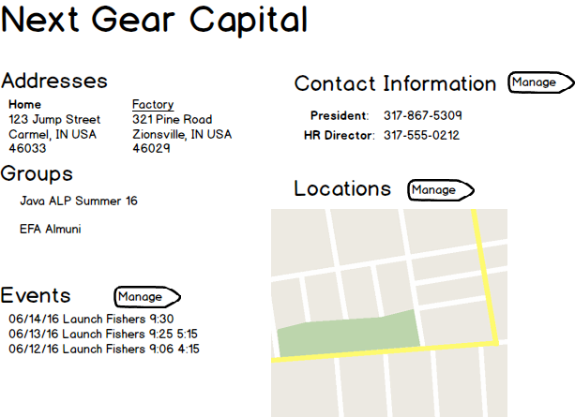A student or teacher needs more information about connecting with an organization, when detail is selected a user will be brought to this view to see all the necessary information.

## Organizations

Organizations — Table of all organizations with a detail button to take you further into specific organization.

When looking for an organization, this will display all the organizations.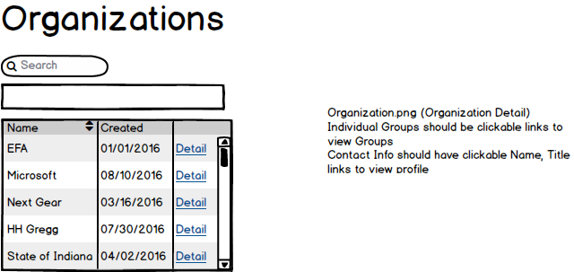

## Properties

## Survey Create

Survey Create — Initial create of a survey, allow for name and question data population.

The teacher has some questions for the class, through the survey functionality the teacher goes here to create a survey for a group(s)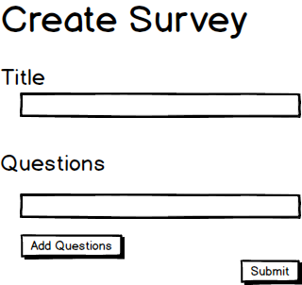

## Survey Responses

Survey Responses — For the admin, the view will display the average responses displayed in stars from 1-5, each question will have an action link to take you into the question and see all responses in text format.

After the survey is completed the teacher can now go through the survey and find how many responses and what responses were given related to the survey.

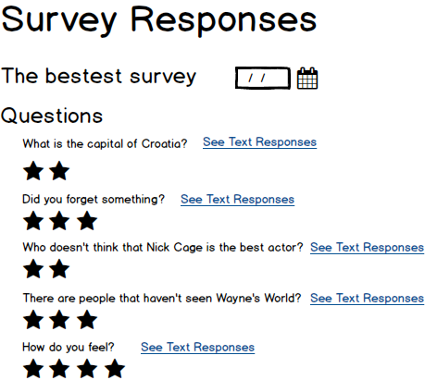

## Survey

## Surveys

Surveys — List of all surveys in a table with action link to go into it.

Since the teacher could make many surveys, this will display all the surveys that teacher has made so that they could go back to it at any time and find the appropriate one.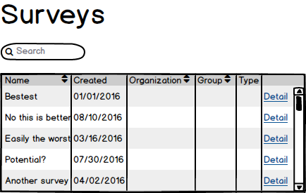

## Timesheet

Timesheet — Admin/User timesheet that displays table showing what day you clocked on and clocked off. *Remove time spent field, it is not necessary

For both teacher and student the timesheet is how each will track and view their individual time logging.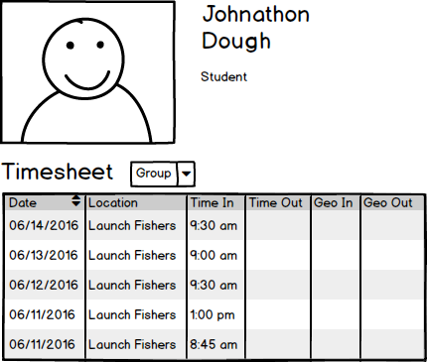

## User Profile

User Profile — Admin side view of individual user where the admin can add the user specifically to groups and have action links directing to relevant information of the user.

very similar to what a user profile is going to be for the creator, this view is for the teacher to view the information of the user, and to move the user to appropriate groups and organizations.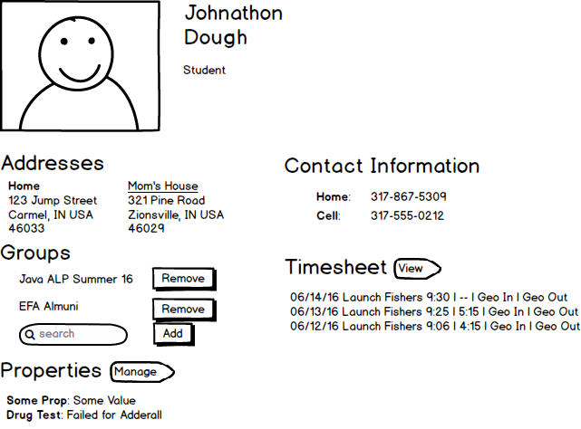

1. **Appendix A – Discussion Records**